|  |  |
| --- | --- |
| **Soal Praktikum**  *Practicum Case* |  |
| T0026  Data Structures |
| **Teknik Informatika**  *Computer Science* | **C1-T0026-YW01** |
| **Periode Berlaku** Semester Pendek 2016/2017  ***Valid on*** *Compact Semester Year 2016/2017* | **Revisi 00**  *Revision 00* |

## Learning Outcomes

* Demonstrate how to create any learned data structure
* Analyze the usage of data structure in application
* Design a proper data structure needed in application

## Topic

* Session 11 - Review Material

## Sub Topics

* Linked List
* Binary Tree
* Binary Search Tree
* AVL Tree
* Heap

## Soal

*Case*

Ragnarok Online is a MMORPG that was popular 3 years ago, but today it still has a lot of big fans. Mr. Setiawan, a Market Research from LYTO, wants to make a program that contains all the players in that game so he asks you to make the program using a binary search tree concept. Here are the descriptions of the program:

* Program consists of 4 menus:

1. Add (PUSH) New Ragnarok Online Player

2. Show Ragnarok Online Player Profile

3. InOrder, PreOrder, PostOrder

4. Exit

* If user chooses **Add (PUSH) New Ragnarok Online Player**, then:

- Ask user to input **player’s name**. The length of **player’s name** must be **between 1 and 20 characters**.

* + Ask user to input **player’s job**. Validate that the player’s job must be **‘Swordsman’, ’Thief’, ’Mage’, or ‘Archer’ with case sensitive**.
  + Then calculate **the level of player**. The level is a random number **between 1 and 100**.

Show the message: **“Player Got Level: [Level]”**

* + Push the data into the tree based on **the level of the player**.
  + If data has been successfully inputted, then show the message **“Success to add new player…”**
  + If tree’s level is already at 4, then show the message: **“Maximum tree level is 4…”**
* If user chooses **Show Ragnarok Online Player Profile**, then:
  + Ask user to input **player’s name**. The length of **player’s name** must be **between** **1 and 20 characters**.
  + If data can be found in the tree, show the player’s profile with format:

**“Player’s Level : [Player’s Level]”**

**“Player’s Name : [Player’s Name]”**

**“Player’s Job : [Player’s Job]”**

* + If data cannot be found, then show the message **“Data that you requested cannot be found…”**
* If user chooses **InOrder, PreOrder, PostOrder,** then:

- If there is no data in the tree, show the message **“There is no data left to be shown…”**

**-** If data is already in the tree, show the inorder, preorder, and postorder of the tree. Please show the level of the player only!

* If user chooses **Exit**, then:

- Delete all data in the linked list.

- Program ends.

**Please run the EXE file to see the sample program.**

**Print Screen of Main Menu**

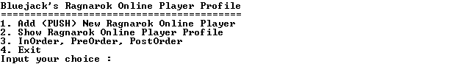

**Print Screen of Add (PUSH) New Ragnarok Online Player Menu (Menu ‘1’)**



**Print Screen of Show Ragnarok Online Player Profile Menu (Menu ‘2’)**

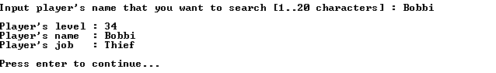

**Print Screen of InOrder, PreOrder, PostOrder Menu (Menu ‘3’)**



**Print Screen of Exit Menu (Menu ‘4’)**

